Cammy Hyde

Creator’s Statement ENGCMP 0610

September 30th, 2024

A Sleepless Night on the Boulevard of the Allies

For my soundscape narrative, I’m documenting a sleepless night in my apartment on the Boulevard of the Allies. This narrative follows a character who begins to fall asleep and is abruptly awoken by the disruptive noises I regularly hear in my apartment. My inspiration for this project came from me trying to fall asleep in my apartment on a Friday night and being unable to because of all the noise around me.

The sounds I focused on in this project were car honks, fire truck noises, sirens, and my neighbors stomping around above me. There’s faint sounds of the crosswalk ticking accompanied with soft car revving, but nothing as prominent or loud as I hoped it to be in the project. This was not only due to technical issues of capturing these sounds myself, but I decided to leave them out entirely because I wanted the piece to be more precise and short.

I didn’t necessarily want to put the listeners through a long, drawn-out experience of hearing loud and invasive noises, but I wanted it to be just enough to get my point across. I knew I wanted to condense the loud noises and layer them on top of each other in order to achieve a kind of crescendo effect. After these loud and noisy sounds ended, I threw in the sound of my alarm to signify that it is now morning and thus the end of a sleepless night. Even though the soundscape is only about 2-3 minutes, it still encapsulates the idea of being kept up all night.

After handing in my first final draft and receiving feedback, I decided to throw in a sighing/groaning sound to add more of the character in this piece. One of the suggestions was to do exactly this in order to really capture the frustration element. I took a voice memo on my phone of me sighing and groaning and then converted it to an mp3 to use in Audacity.

I also want to point out that my sound effects of the car honks and fire trucks were taken from the internet. I captured both of these sounds authentically, but I found that even with the amplify effect on Audacity it wasn’t nearly as loud or obnoxious as I wanted these sounds to be. I also had the issue of the sounds not being loud enough for a long enough time; for the fire trucks they would pass by too quickly (obviously to go put out a fire somewhere) and the car honks would usually be short beeps that weren’t as loud as I wanted them to be.

Screenshots

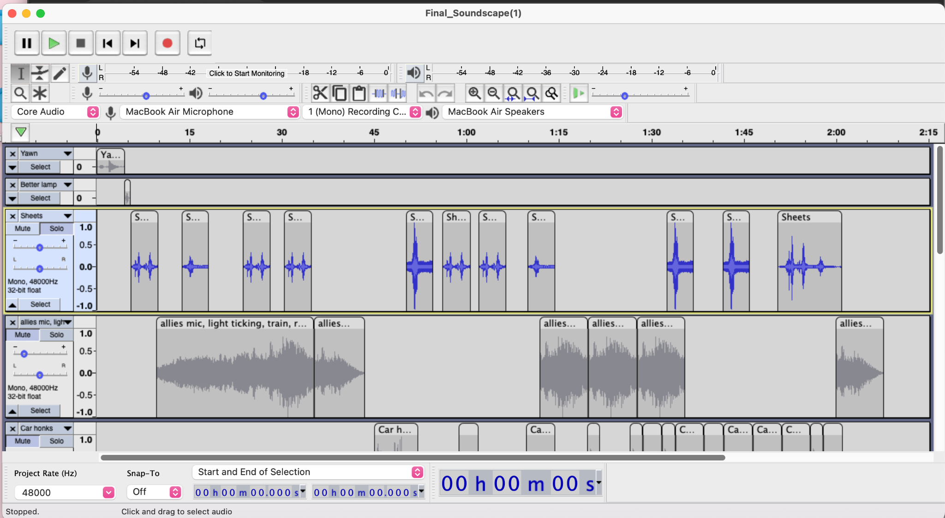

Sheets sound effect

* The sounds highlighted here are noises of the main character tossing and turning at night, unable to fall asleep.

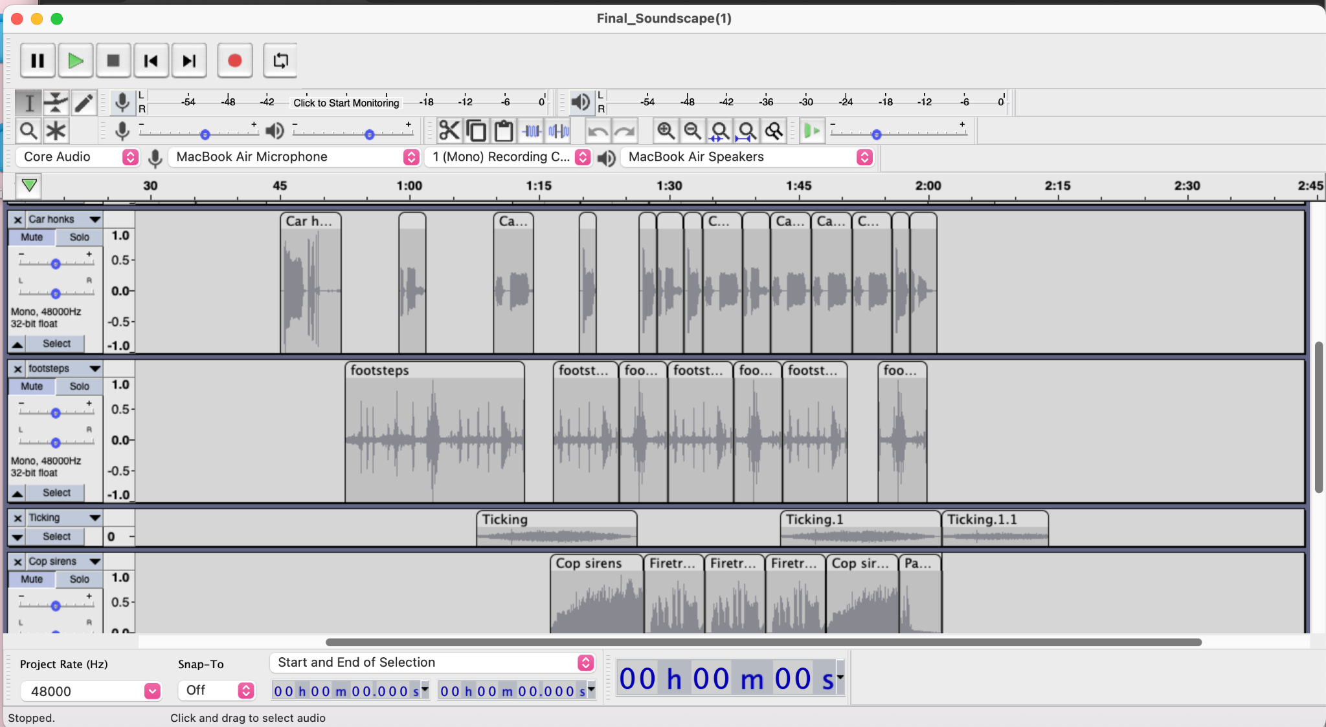

Layering of car honks, fire trucks, and sirens

* The sounds here are layered to create a crescendo effect to create the stressful and frustrating feeling

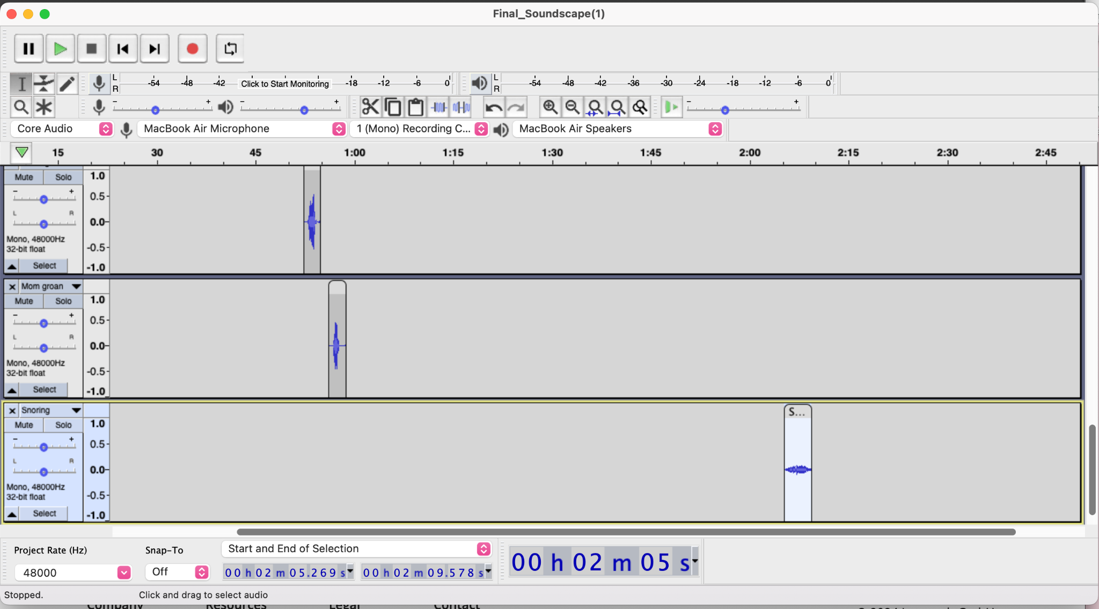

Sighing, groaning, and light snoring sounds

* Sounds I added after my soundscape draft. I added these sounds to give the character in this soundscape more of a presence.